DAA Mini Project

Title: Implementation and Comparison of Naive String Matching and Rabin–Karp Algorithm

Objectives: 1) To implement the Naive String Matching algorithm for searching a pattern in a given text.
2) To implement the Rabin–Karp algorithm using hash values.
3) To identify all occurrences of a pattern in the given text.

Problem Statement: Implement the Naive string matching algorithm and Rabin-Karp algorithm for string matching. Observe difference in working of both the algorithms for the same input.

Outcomes: 1) Understand the working of string matching algorithms.
2) Implement pattern searching techniques using C++.
3) Apply the hashing technique in the Rabin–Karp algorithm.

Software and Hardware Requirements:
Software:- Operating System, g++ compiler, Cpp, any suitable IDE
Hardware:- Intel i3+ processor, 6GB+ RAM, 32GB+ storage

Theory:
A. Naive String Matching Algorithm
The Naive String Matching algorithm is a simple pattern-searching algorithm. It checks whether the given pattern matches the text at every possible position. Characters are compared one by one. If all characters match, the starting index is displayed. Otherwise, the algorithm shifts the pattern by one position and repeats the process.
Example:
Text: ABABCABC
Pattern: ABC
The pattern occurs at indices 2 and 5.

Time Complexity:
- Best case: O(n)
- Worst case: O(nm)

B. Rabin–Karp Algorithm
The Rabin–Karp algorithm uses hashing to search for a pattern in a text. It calculates hash values for the pattern and the first text window of equal length. If the hash values match, it compares the actual characters to confirm the match. It then updates the text window's hash using a rolling hash technique and continues searching.
This approach can avoid unnecessary character-by-character comparisons when hash values differ.
Time Complexity:
- Expected case: O(n+m)
- Worst case: O(nm), due to hash collisions and character comparisons.
Here, n is the length of the text and m is the length of the pattern.

Algorithm:
- Naive String Matching Algorithm
Step 1:- Start
Step 2:- Read the text and pattern from the user.
Step 3:- Calculate the lengths of the text and pattern.
Step 4:- Place the pattern at the beginning of the text.
Step 5:- Compare the pattern characters with the corresponding text characters.
Step 6:- If all characters match, display the starting index.
Step 7:- Shift the pattern one position to the right.
Step 8:- Repeat until all possible positions have been checked.
Step 9:- Display all matching positions.
Step 10:- Stop.
- Rabin–Karp Algorithm
Step 1:- Start.
Step 2:- Read the text and pattern from the user.
Step 3:- Calculate the lengths of the text and pattern.
Step 4:- Calculate the hash values of the pattern and the first text window.
Step 5:- Compare the two hash values.
Step 6:- If the hash values match, compare the actual characters to verify the match.
Step 7:- If the pattern matches, display its starting index.
Step 8:- Calculate the hash value of the next text window using the rolling hash technique.
Step 9:- Repeat until all possible positions have been checked.
Step 10:- Display all matching positions.
Step 11:- Stop.

Program:
#include <iostream>
#include <string>
#include <ctime>
using namespace std;

// Naive String Matching
void naiveSearch(string text, string pattern){
int n = text.length();
int m = pattern.length();
bool found = false;
for (int i = 0; i <= n - m; i++){
int j;
for (j = 0; j < m; j++){
if (text[i + j] != pattern[j])
break;
}
if (j == m){
cout << "Pattern found at index " << i << endl;
found = true;
}
}
if (!found)
cout << "Pattern not found" << endl;
}

// Rabin-Karp Algorithm
void rabinKarp(string text, string pattern){
int n = text.length();
int m = pattern.length();

int d = 256;
int q = 101;
int h = 1;
int p = 0;
int t = 0;
bool found = false;

for (int i = 0; i < m - 1; i++)
h = (h * d) % q;
for (int i = 0; i < m; i++){
p = (d * p + pattern[i]) % q;
t = (d * t + text[i]) % q;
}
for (int i = 0; i <= n - m; i++){
if (p == t){
int j;
for (j = 0; j < m; j++){
if (text[i + j] != pattern[j])
break;
}
if (j == m){
cout << "Pattern found at index " << i << endl;
found = true;
}
}
if (i < n - m){
t = (d * (t - text[i] * h)
+ text[i + m]) % q;

if (t < 0)
t += q;
}
}

if (!found)
cout << "Pattern not found" << endl;
}

int main()
{
string text, pattern;

cout << "Enter text: ";
getline(cin, text);

cout << "Enter pattern: ";
getline(cin, pattern);

if (pattern.empty())
{
cout << "Pattern cannot be empty." << endl;
return 0;
}

if (pattern.length() > text.length())
{
cout << "Pattern not found." << endl;
return 0;
}

clock_t start, end;
double naiveTime, rkTime;

cout << "\n--- Naive String Matching ---" << endl;
start = clock();
naiveSearch(text, pattern);
end = clock();
naiveTime = double(end - start) / CLOCKS_PER_SEC;

cout << "Execution time: " << naiveTime
<< " seconds" << endl;

cout << "\n--- Rabin-Karp Algorithm ---" << endl;
start = clock();
rabinKarp(text, pattern);
end = clock();
rkTime = double(end - start) / CLOCKS_PER_SEC;

cout << "Execution time: " << rkTime
<< " seconds" << endl;

cout << "\n--- Performance Comparison ---" << endl;
cout << "Naive Time: " << naiveTime << endl;
cout << "Rabin-Karp Time: " << rkTime << endl;

return 0;
}

Output:-
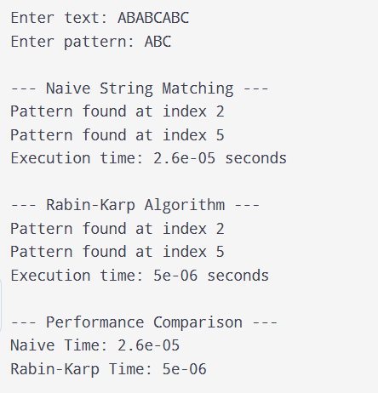

Conclusion: The Naive String Matching and Rabin–Karp algorithms were successfully implemented. Both algorithms found the pattern correctly. Their execution times were compared to analyze their performance.

